Human Geography

Research Methods & Techniques

Quantitative Methods Component

Dr. Aslan Zorlu

15 september 2020

Borja Vilar Martos

Alexandra Giannopoulou 13285122

Carmen Sauren 11308427

**Introduction and theory**

The focus of this small social geographical paper will be on a statistical question. We are focusing on the effect of different factors to housing mobility in 4 municipalities in the Netherlands – Amsterdam, Hague, Rotterdam and Utrecht. We will examine the moving probability of several households in these areas, depending on the age of the household’s members, their ethnic origin, education level, ownership status and the value of the house. By the end of this paper, we aim to have answered the question *to which extent the aforementioned factors affect the household’s moving probability*.

According to Van Ham and Clark (2009), “both the socio-economic status of neighborhoods (Harris, 1999) and the ethnic mix of the neighborhood population (Clark, 1992; Crowder, 2000) have been linked to residential mobility”.

**Data and methods**

*Data*

We will look into a dataset that is provided to us by the University of Amsterdam, 2015 WoONOnderzoek. The variables that we are focussing on to answer our main research question are as follows. The age of house owners, their educational background, their place of residency,

In order to properly analyse the data, linear regression models are used.

For this research, we have only taken into account people that have an explicit desire to move, or have no desire to move. We disregarded the data on people that were *forced to move* and data on people that had already *found a hous*e, as the potential ambiguity of the interpretation on the answer had the potential to skew our results. Additionally, we also considered these results to be MCAR (missing completely at random), as we posited several reasons why one might mean one or the other. Regardless, the amount of these marginal cases were minimal, meaning the impact on our results would be insignificant.

*Variables*

The variables 1.724 more tenants than homeowners.

Carmen: probable on your to-do list but please remember to add how we turned the education (nominal) variable into a numeric one.

Also it’d be nice to focus on the idea that we have only considered “complete data”, in order to maximise accuracy of the model. That also allows you to drop the “Anders” answer from the education question, as it might skew the model.

*For reference= n=6962*

**Results**

Our logistic regression results show indeed a correlation among the mentioned variables, which push the person in question to possess the desire to move, or on the contrary, to stay. However, such a diverse multivariate answer, that has such a heavy qualitative aspect to it, will often show little in terms of absolute certainty, and these will often be the more rare cases.

In the table below (*Table* ), we can see the results of the logistic regression. As expected, we can appreciate that the dependent variable, here dubbed ‘*verhuisgeneigd’* as per the original data, will get increasingly closer to 1 as the resident shows a higher inclination to move away.

It is important to mention that for a few several variables, we have approached the results from a methodology of *marginal effects,* meaning that our baseline that we can compare to would be a *Rental,* for the *huko* variable; *Native Dutch,* for the *etniop3* (ethnic origin) category; and *Amsterdam,* for the *g4_5* (municipality) variable. 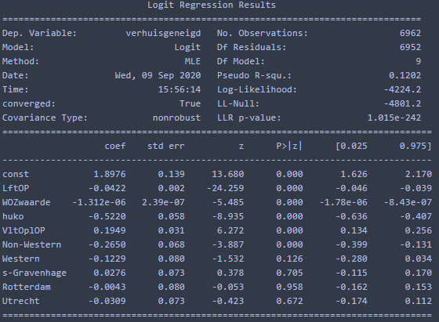

The interpretation of the results as per the ordinal variables follows the expected hypothesis: there are overall trends by which the unwillingness to move (*y = 0)* increases as the resident gets older (*LftOP*), and as the inhabited house goes up in value (*WOZwaarde*), as the nicer the house, the happier a resident would be.

Interestingly, the higher the education, the more likely a person is to have the desire to move. Although at first this may contradict the results of the *house value* variable, it is important to remember that the level of education is not a consistent indicator of personal wealth *per household.* Additionally, we theorise that university-educated people tend to have an

**Conclusion**